**SYNOPSIS OF REACT JS PROJECT “PORTFOLIO”**

**INTRODUCTION**

I have made a project portfolio in which I present about my skills and projects.

I had used react.js library to enhance ux/ui of my website. The main objective of ReactJS is to develop User Interfaces (UI) that improves the speed of the apps. It uses virtual DOM (JavaScript object), which improves the performance of the app. The JavaScript virtual DOM is faster than the regular DOM. We can use ReactJS on the client and server-side as well as with other frameworks. It uses component and data patterns that improve readability and helps to maintain larger apps.

Why learn ReactJS?

Today, many JavaScript frameworks are available in the market (like angular, node), but still, React came into the market and gained popularity amongst them. The previous frameworks follow the traditional data flow structure, which uses the DOM (Document Object Model).

homepage

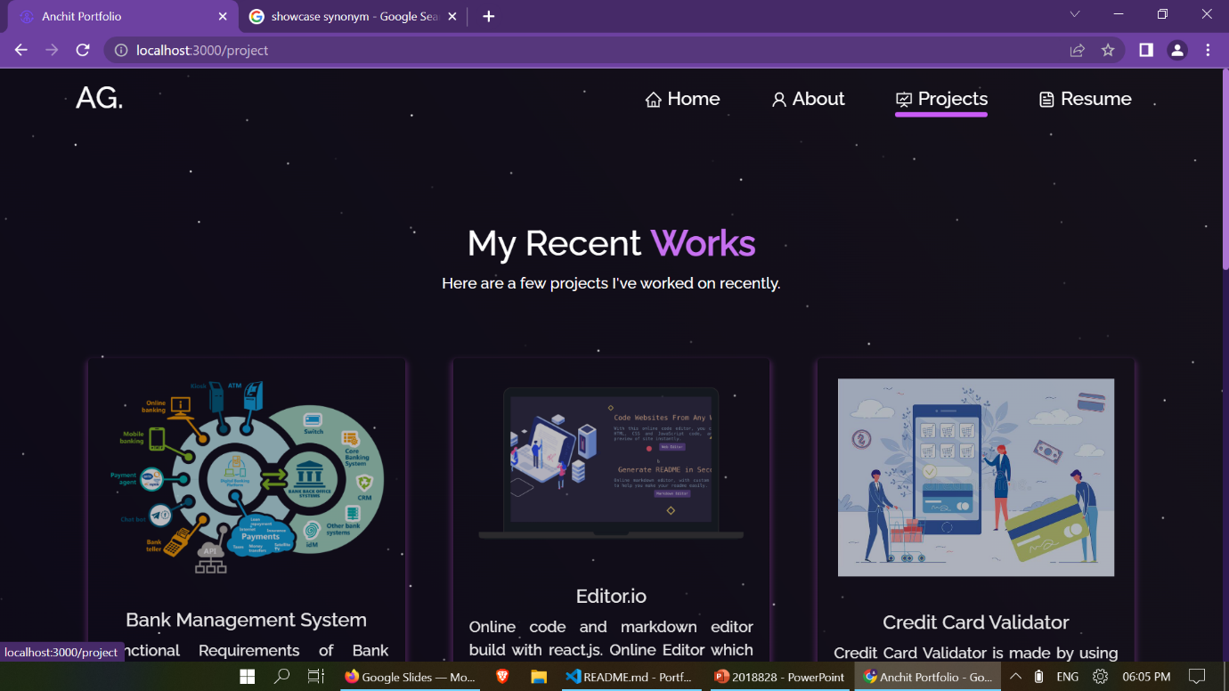

Localhost:3000/project

**Applications**

Few popular websites powered by React library are listed below −

Facebook, popular social media application

Instagram, popular photo sharing application

Netflix, popular media streaming application

Code Academy, popular online training application

Reddit, popular content sharing application

**TECHNOLOGY USED**

I have mainly used **React JS** as the main technology to develop my project. Apart from that I have also implemented our project using the React styled-component and material UI. The main reason for choosing React to develop my project is that React is a dynamic tool for developing single page applications.

**JavaScript library**

A strong blend of JavaScript and HTML syntax is always used, which automatically simplifies the entire process of writing code for the planned project. The JS library consists of several functions including one that converts the HTML components into required functions and transforms the entire project so that it is easy to understand.

**HTML** was developed with the intent of defining the structure of documents like headings, paragraphs, lists, and so forth to facilitate the sharing of scientific information between researchers. Now, HTML is being widely used to format web pages with the help of different tags available in HTML language.

**Cascading Style Sheets**, majorly referred to as **CSS**, is a simple design language intended to simplify the process of making web pages presentable. key advantages of learning CSS

**FEATURES OF THIS APPLICATION**

This application provides the details about myself, my past workdone and projects.

This application presents my web development skills like react.js.

App is use of Languages

JavaScript 60.7%

CSS 35.1%

HTML 4.2%

**HARDWARE AND SOFTWARE REQUIREMENTS**

As required a Node JS software and VS code to run our React JS code. It can be installed simply by downloading it from google.

System requirements for installing vs code:

Hardware recommended:

1.6 GHz or faster processor

1 GB of RAM

Platforms

VS Code is supported on the following platforms:

Windows 8.0, 8.1 and 10, 11 (32-bit and 64-bit)

Linux (Debian): Ubuntu Desktop 16.04, Debian 9

OS requirements: Windows 10 version 1703 or higher: Home, Professional, Education, and Enterprise

Here are the minimum hardware and software requirement for virtual assistant.

Hardware:

• Pentium-pro processor or later.

• RAM 2GB or more.

System requirements for installing node JS

Windows 10 OS.

4 GB RAM.

10 GB free space.

**CONCLUSION**

This project enhances my web development skills that helps to develop more effective and robust web applications by using react.js.

Portfolios are a great way to demonstrate the competencies you would list on a resume or talk about in an interview — they allow you to show and not just tell. During a job search, the portfolio showcases your work to potential employers. It presents evidence of your relevant skills and abilities.

This portfolio can be accessed by anyone to see what my skills are and the projects I had done and I will improve this website with including forms, chatbots and many more stuff available in react.js and next.js.

**REFERENCES**

Websites:

<https://reactjs.org/docs/getting-started.html>

<https://www.w3schools.com/REACT/DEFAULT.ASP>

<https://www.w3schools.com/html/default.asp>

<https://docs.npmjs.com/>

<https://nodejs.org/en/docs/>

<https://code.visualstudio.com/download#>

<https://github.com/facebook/react>

Github: (for full code)

<https://github.com/anchitgupta01/Portfolio-master>